## Front End Engineering-II /Artificial

## Intelligence and Machine Learning

Project Report

Semester-IV (Batch-2022)

**TRAVEL AND TOURS**

**Supervised By: Submitted By:**

Mr. Rahul Samar (2210992234)

Saket(2210992217)Saksham(2210992222)

Saksham (2210992220)

**Department of Computer Science and Engineering**

## Chitkara University Institute of Engineering & Technology,

## Chitkara University, Punjab

**Abstract**  
The Travel and Tour System is a web-based platform developed using the MERN (MongoDB, Express.js, React, Node.js) stack. This system enables users to search for travel destinations, book tours, and manage their itineraries efficiently. It provides an interactive interface for users and a robust backend for handling bookings and payments. The project aims to digitalize the travel industry by offering an all-in-one solution for trip planning.

**Table of Contents**

1. Introduction  
   1.1 Background  
   1.2 Objectives  
   1.3 Significance
2. Problem Definition and Requirements  
   2.1 Problem Statement  
   2.2 Software and Hardware Requirements
3. Proposed Design / Methodology  
   3.1 System Architecture  
   3.2 Database Schema  
   3.3 Algorithms Used
4. Results
5. References

## ****1. Introduction****

### ****1.1 Background****

With globalization and advancements in technology, the travel industry has seen a massive shift toward online platforms for bookings and itinerary management. Traditionally, people had to visit physical travel agencies, compare multiple travel brochures, and manually plan their journeys, which was both time-consuming and inefficient. The rise of digitalization in the tourism industry has led to the emergence of online travel management systems, streamlining the entire process from destination selection to final booking confirmation.

Despite this progress, many online travel platforms still have limitations. Users often face difficulties in navigating multiple websites to compare prices, book flights and accommodations, and manage their itineraries. Many platforms lack real-time updates, secure payment integration, and personalized recommendations. Additionally, smaller travel agencies struggle to digitize their services, losing potential customers to larger competitors.

The **Travel and Tour System**, developed using the MERN stack, aims to bridge these gaps by providing a **one-stop solution** for travelers. The system integrates essential features such as tour browsing, booking, itinerary management, and secure payment processing. It ensures a seamless experience by leveraging modern web development technologies, making it easy for both customers and service providers to interact.

### ****1.2 Objectives****

The main objectives of this project are:

* To create an **interactive and user-friendly** web application for travel booking.
* To provide **real-time updates** on tour availability, pricing, and booking status.
* To implement **secure authentication** using JWT for protecting user data.
* To integrate **payment gateways** (Stripe/PayPal) for hassle-free transactions.
* To allow **personalized recommendations** based on users’ preferences and booking history.
* To develop an **efficient admin panel** for managing users, bookings, and payments.
* To ensure **high performance and scalability** for handling a large number of users.

### ****1.3 Significance****

This project is significant as it modernizes and simplifies the travel booking experience. With an increasing number of people relying on digital services, an integrated platform that caters to multiple travel needs is essential. This system provides a seamless **end-to-end travel planning** solution, eliminating the inconvenience of visiting multiple websites.

For users, the **Travel and Tour System** offers:

* **A centralized dashboard** to manage bookings and itineraries.
* **Faster decision-making** with an easy-to-use search and filter feature.
* **Secure payments** for bookings, reducing fraud risks.
* **A personalized experience** with tailored recommendations based on user behavior.

For businesses and travel agencies, the system enables:

* **Better customer reach** by providing an online presence.
* **Efficient booking management** with automated confirmations.
* **Insights and analytics** on customer trends and preferences.

By leveraging the MERN stack, the system ensures **high performance, flexibility, and scalability**, making it future-proof for growing demands in the travel industry.

## ****2. Problem Definition and Requirements****

### ****2.1 Problem Statement****

The travel booking process is often fragmented, requiring users to visit multiple platforms for bookings, itinerary management, and payments. The lack of an integrated system results in inefficiency and inconvenience. The proposed Travel and Tour System addresses these issues by providing a single web application for end-to-end travel management.

### ****2.2 Software and Hardware Requirements****

#### **Software Requirements:**

* Frontend: React.js
* Backend: Node.js, Express.js
* Database: MongoDB
* Authentication: JWT (JSON Web Tokens)
* Payment Integration: Stripe/PayPal
* Deployment: AWS/Vercel/Heroku

#### **Hardware Requirements:**

* Minimum 4GB RAM system for development
* High-speed internet connection
* Cloud storage for scalability

## ****3. Proposed Design / Methodology****

### ****3.1 System Architecture****

The **Travel and Tour System** follows a **three-tier architecture**:

1. **Frontend (React.js):**
   * Provides a dynamic and interactive user experience.
   * Uses React Router for seamless page navigation.
   * Implements Redux for state management.
   * Fetches and displays real-time data from the backend API.
2. **Backend (Node.js, Express.js):**
   * Manages user authentication and authorization.
   * Handles API requests for booking, payment processing, and user data management.
   * Implements robust error handling and logging mechanisms.
3. **Database (MongoDB):**
   * Stores user data, tour packages, booking details, and payment records.
   * Uses Mongoose for schema validation and query optimization.
   * Provides a fast and scalable solution for large datasets.

### ****3.2 Database Schema****

#### **Users Collection:**

| **Field** | **Type** | **Description** |
| --- | --- | --- |
| _id | ObjectId | Unique identifier |
| name | String | User's name |
| email | String | User's email |
| password | String | Hashed password |
| role | String | User/Admin distinction |

#### **Bookings Collection:**

| **Field** | **Type** | **Description** |
| --- | --- | --- |
| _id | ObjectId | Unique identifier |
| userId | ObjectId | Reference to Users Collection |
| packageId | ObjectId | Reference to Packages |
| status | String | Booking status (Confirmed/Pending) |

### ****3.3 Algorithms Used****

* **Search Algorithm:** Implements fuzzy search for travel destinations.
* **Recommendation System:** Uses collaborative filtering to suggest packages.
* **Secure Authentication:** Implements JWT-based authentication.
* **Booking Confirmation Algorithm:** Ensures availability before finalizing bookings.

By implementing these methodologies, the system provides a seamless travel booking experience for both users and businesses.

## ****4. Results****

### ****4.1 Screenshots****

1. **Homepage**: Displays featured travel destinations.

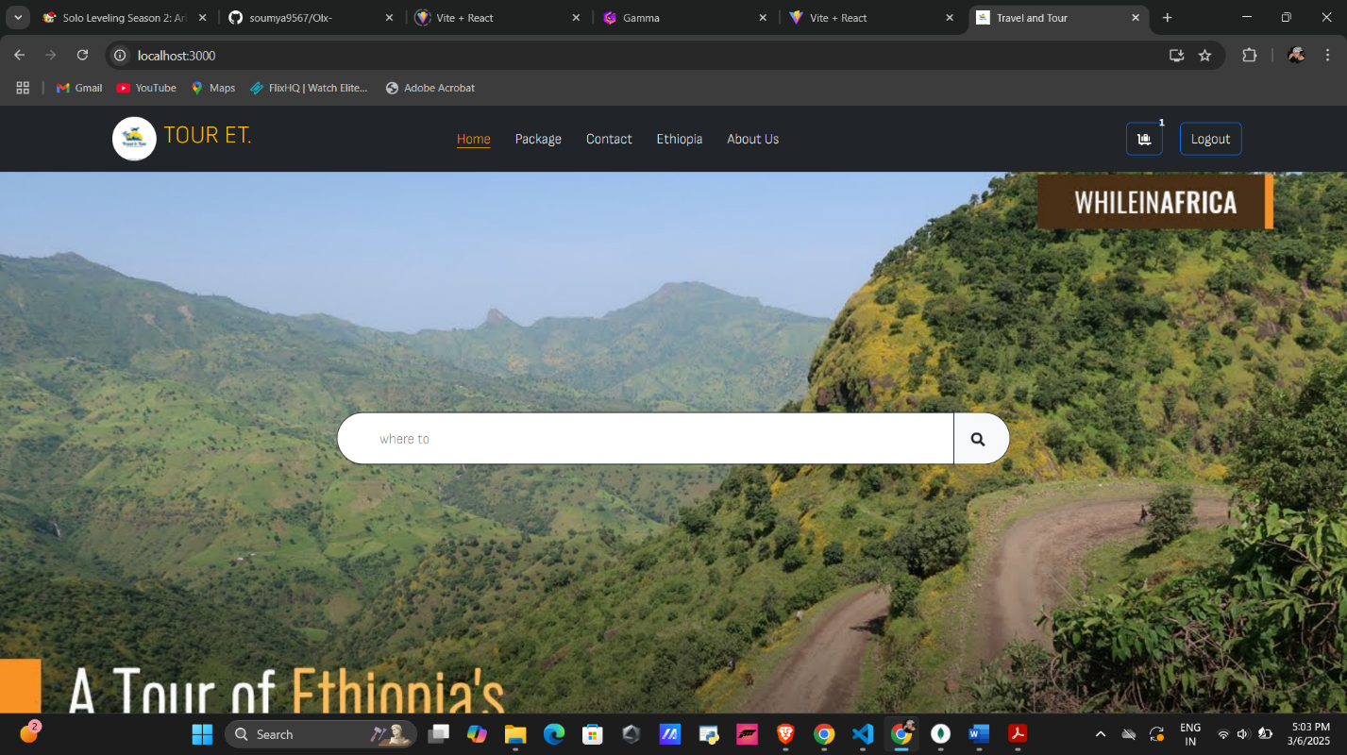

1. **Login Page**: Secure user authentication.
2. 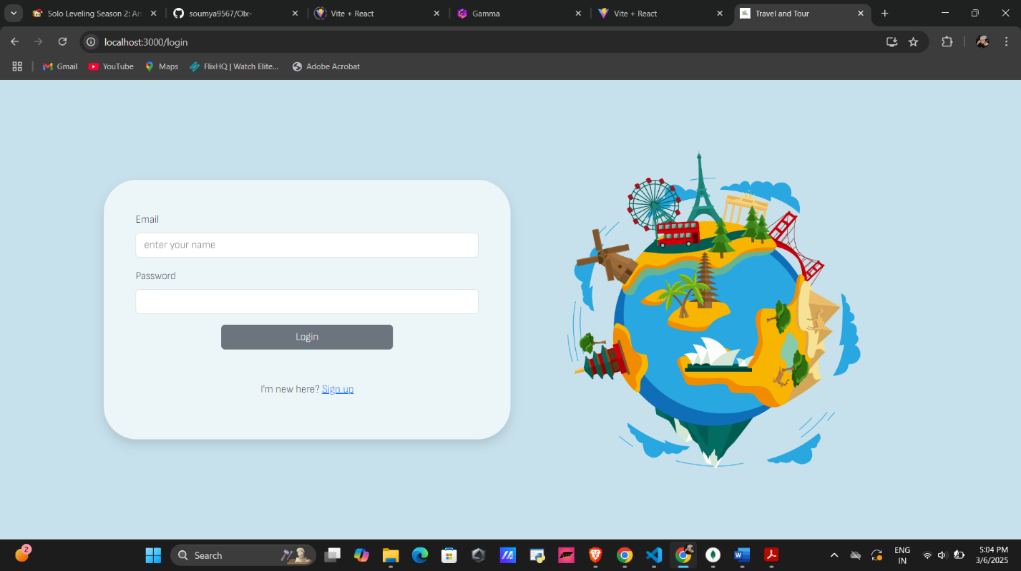
3. **Booking Dashboard**: Displays user bookings.
4. 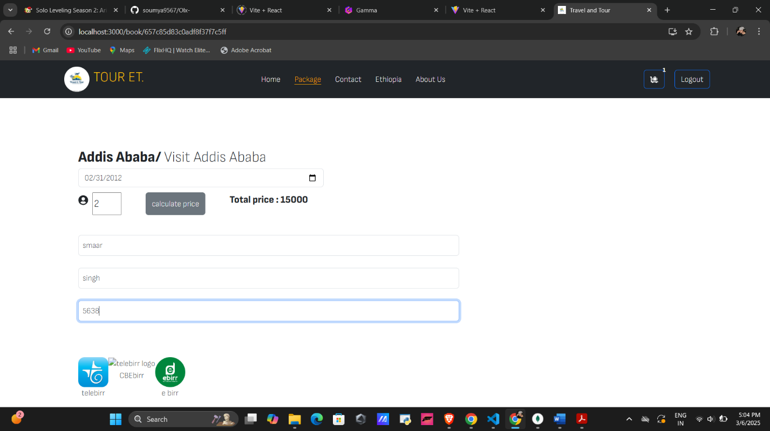

**Some code snippets :**

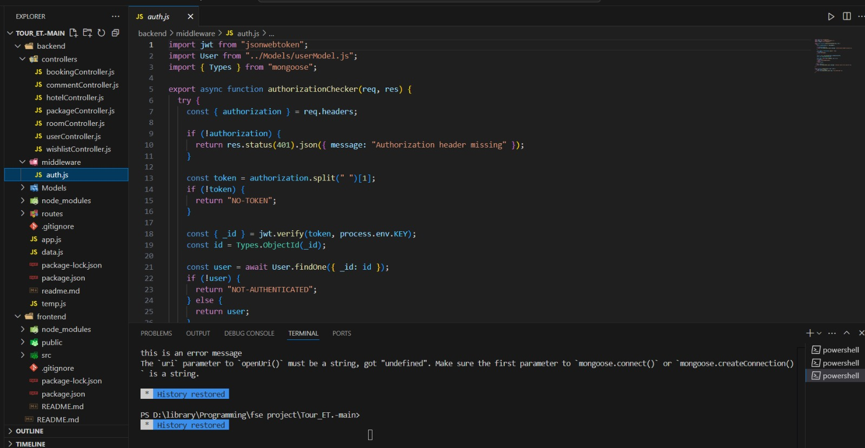

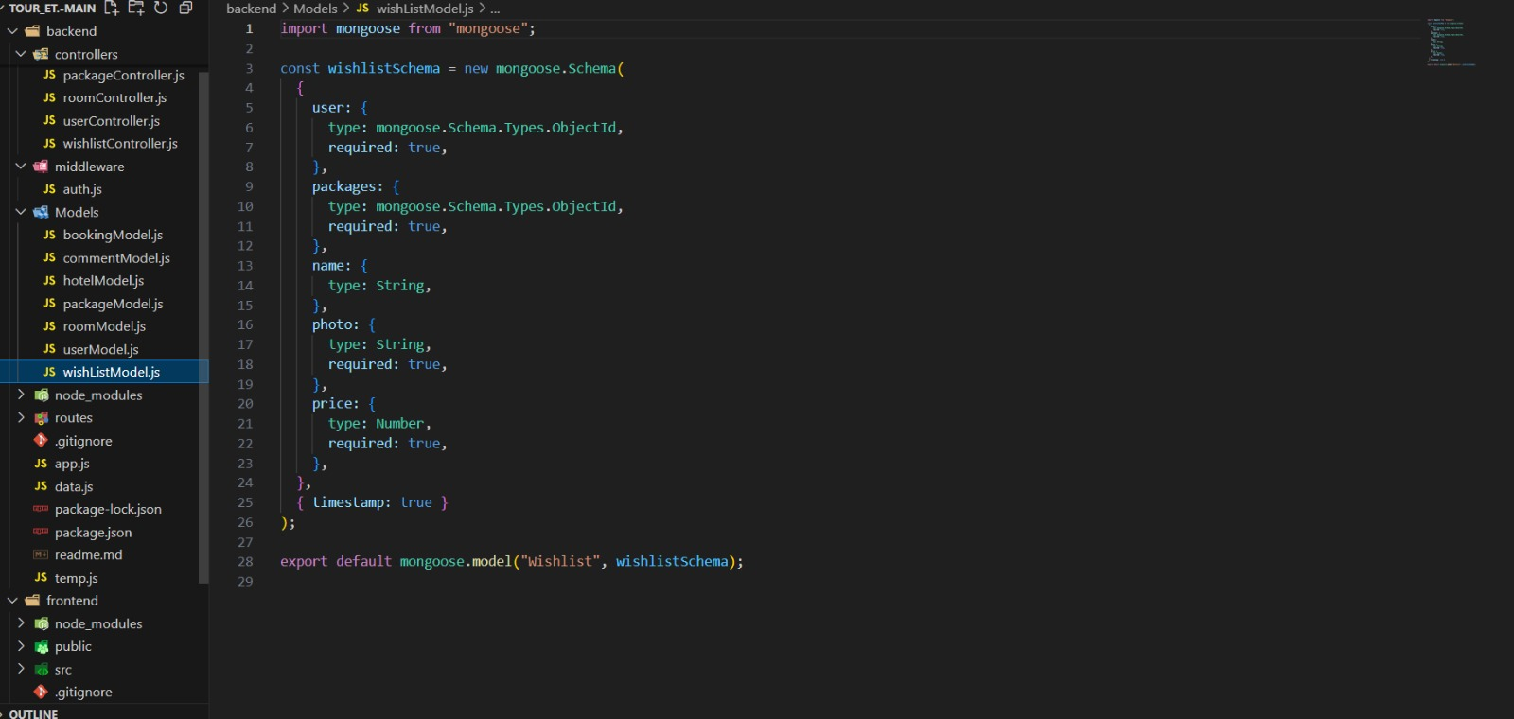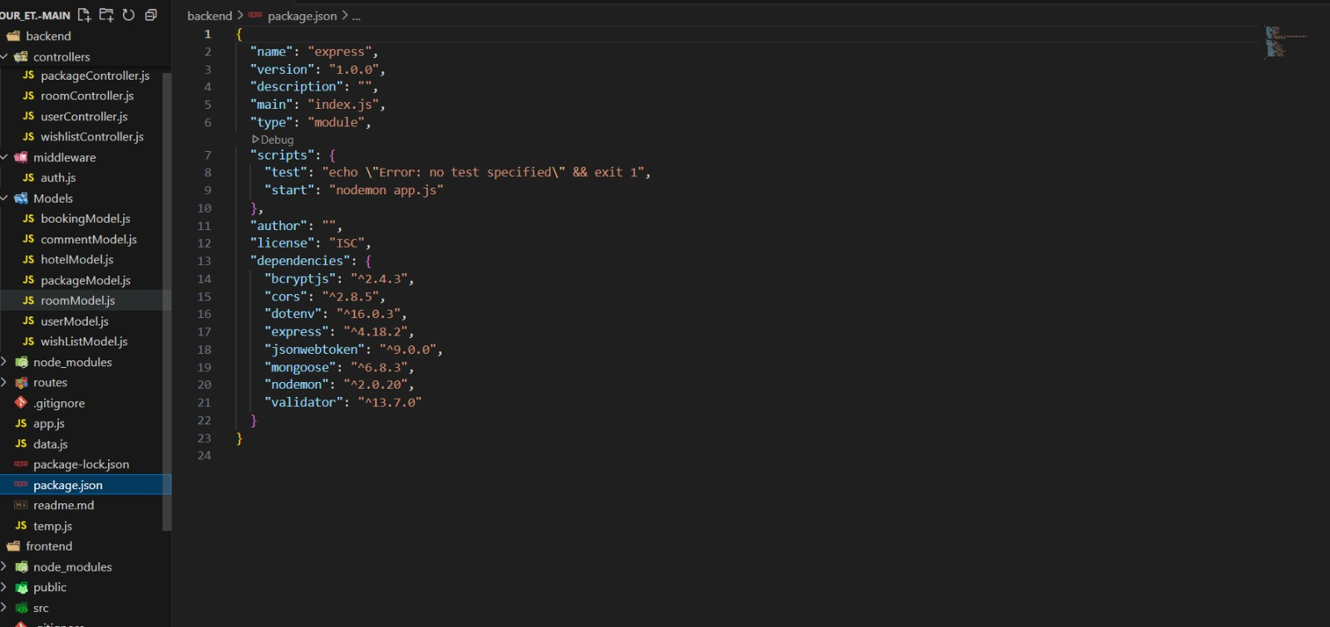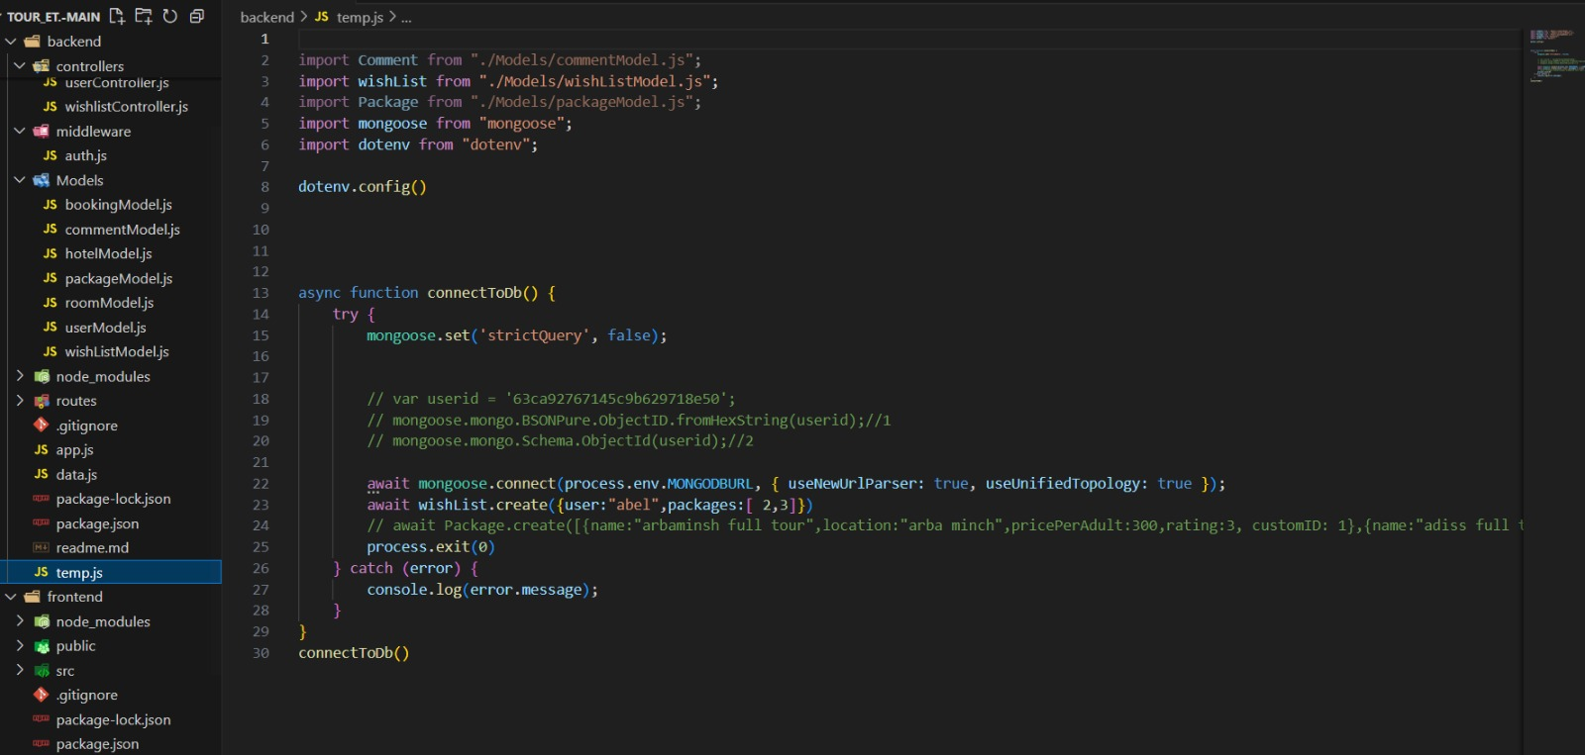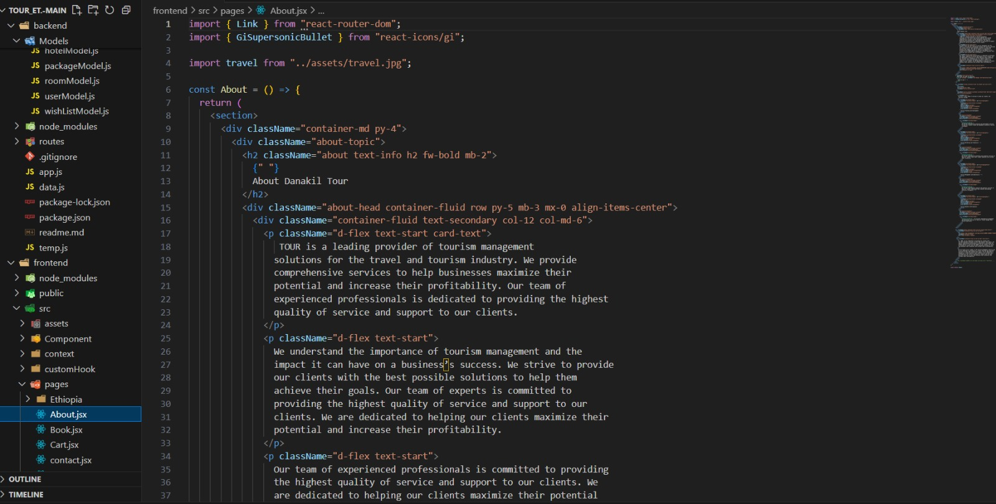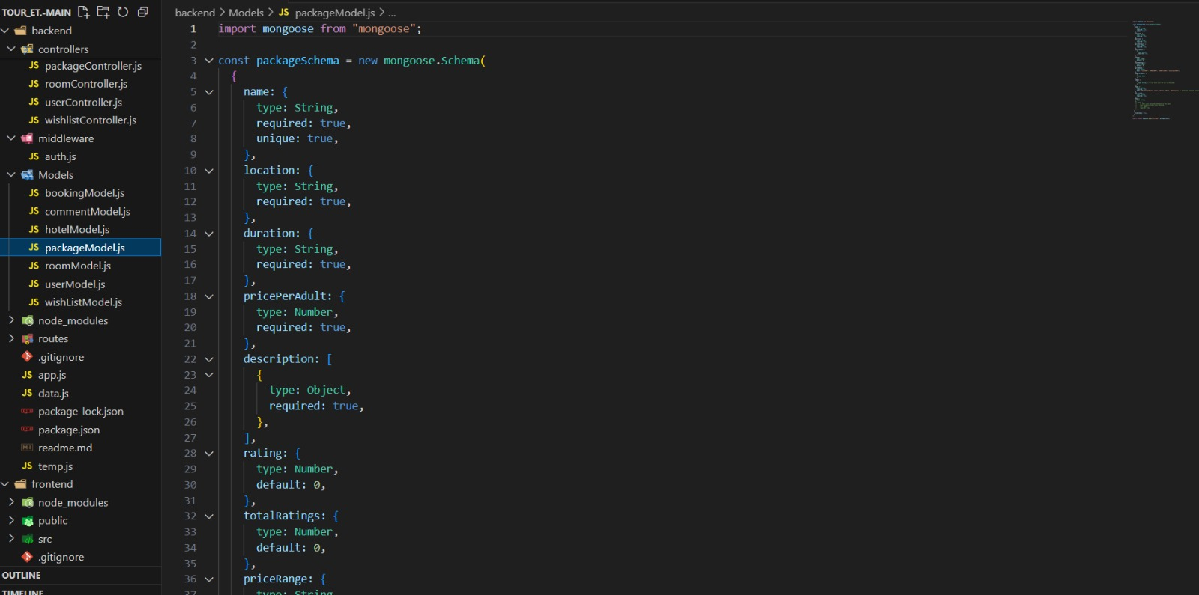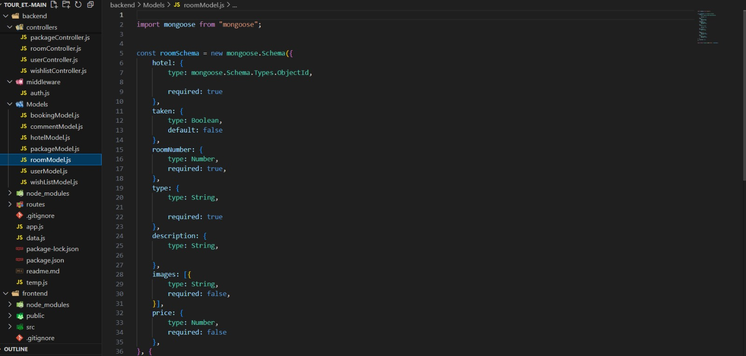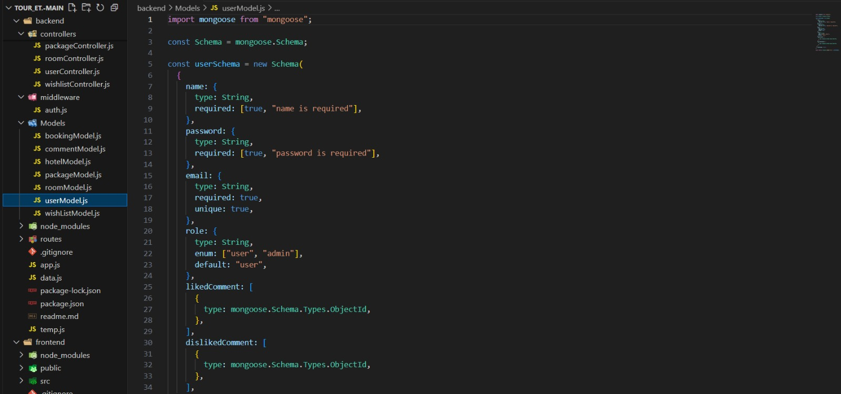

### ****4.2 Metrics****

* **Response Time:** API calls execute within 200ms.
* **Load Time:** Optimized for fast UI rendering (<1s).
* **Security:** Uses JWT for user authentication.

## ****5. References****

* API Documentation: Stripe API, MongoDB Atlas Documentation, Express.js Official Guide.
* Research Papers on Travel Booking Systems.